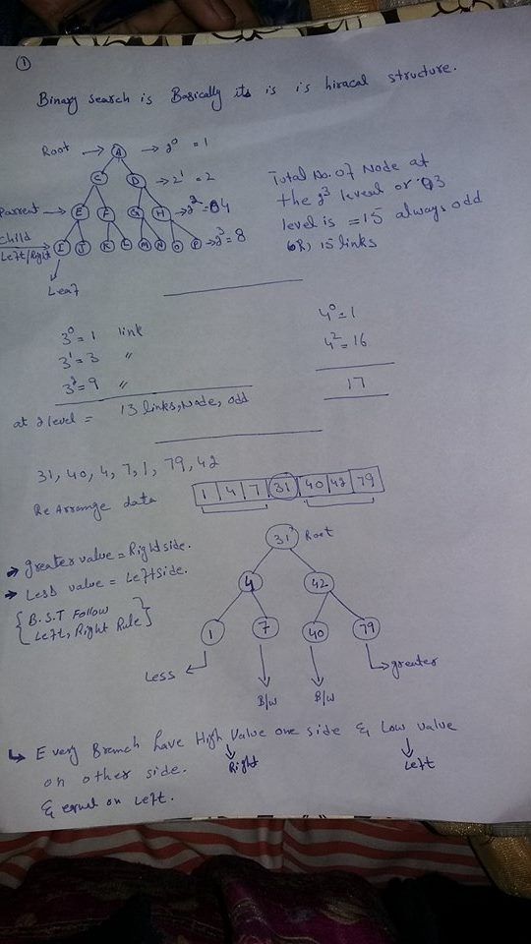

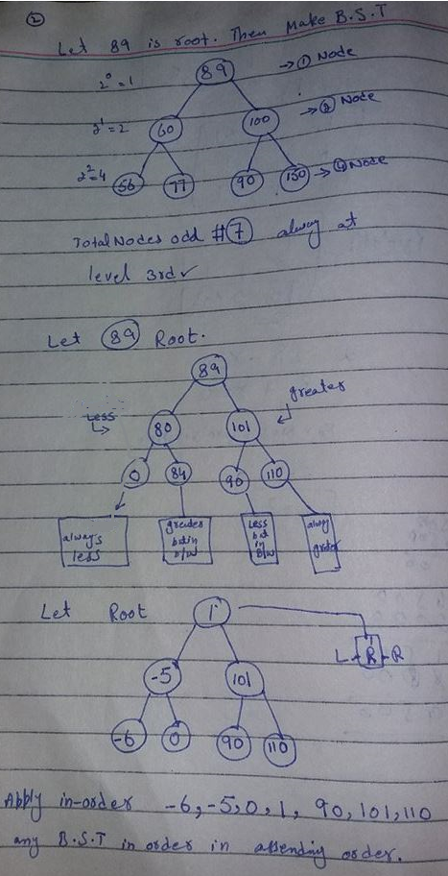

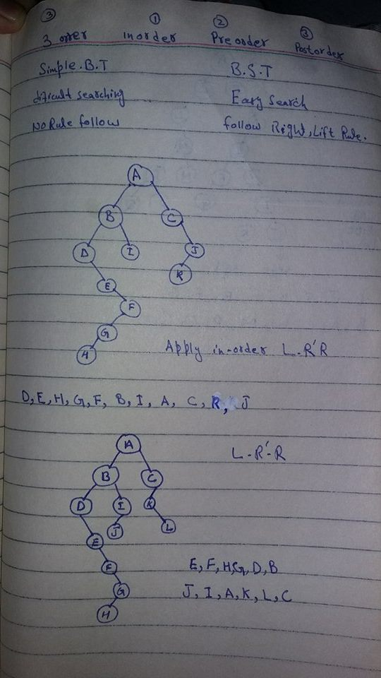

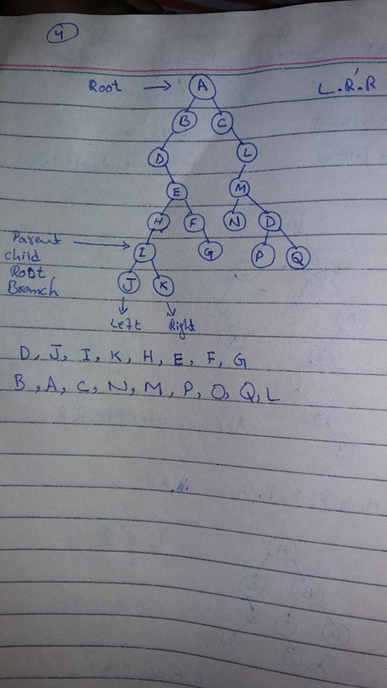

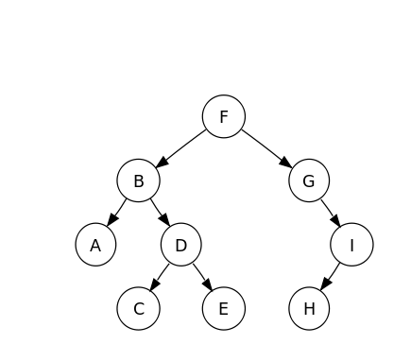

Preorder

This can be summed up as

1. Visit the root node (generally output this)
2. Traverse to left subtree
3. Traverse to right subtree

And outputs the following: F, B, A, D, C, E, G, I, H

In order

This can be summed up as

1. Traverse to left subtree
2. Visit root node (generally output this)
3. Traverse to right subtree

And outputs the following: A, B, C, D, E, F, G, H, I

Post order

This can be summed up as

1. Traverse to left subtree
2. Traverse to right subtree
3. Visit root node (generally output this)

And outputs the following: A, C, E, D, B, H, I, G, F

**Rule of thumb**[[edit](https://en.wikibooks.org/w/index.php?title=A-level_Computing_2009/AQA/Problem_Solving,_Programming,_Operating_Systems,_Databases_and_Networking/Programming_Concepts/Tree_traversal_algorithms_for_a_binary_tree&action=edit&section=4" \o "Edit section: Rule of thumb)]

There is an easier way to remember how to do this and if you are struggling for time in the exam you can try this way:

1. Check that the code is left traversal followed by right traversal
2. Check the position of the output line
3. draw the dots on the nodes
4. draw a line around the tree
5. follow the line and write down each node where you meet a dot

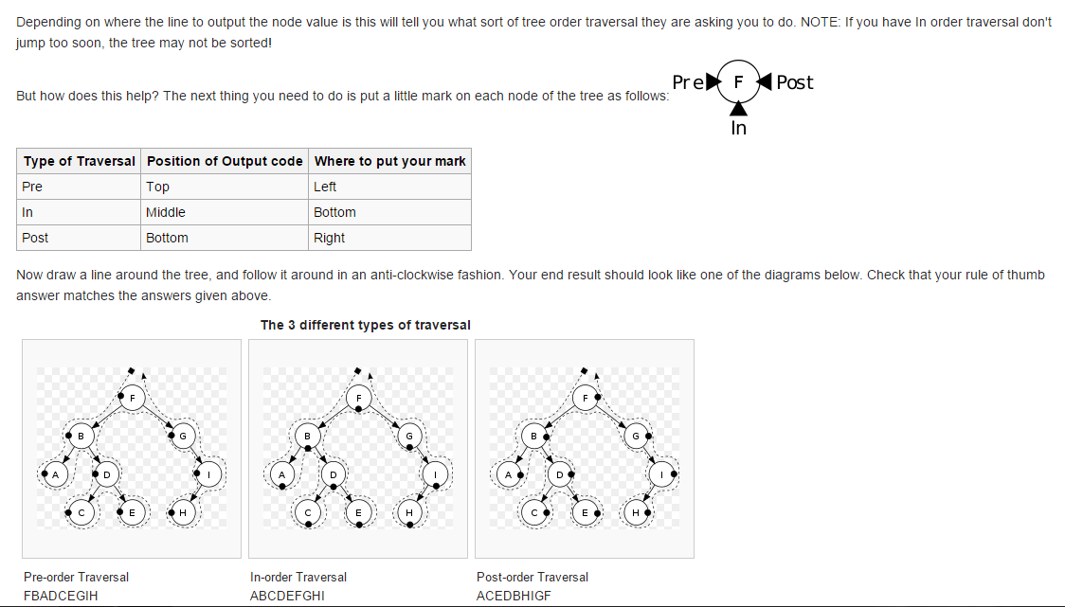

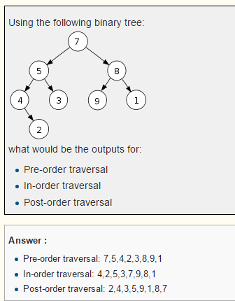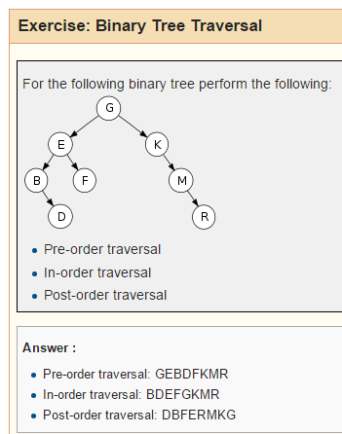

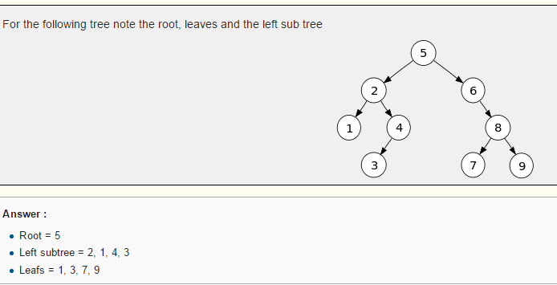

Create a binary tree for the following data input:

5, 2, 6, 8, 4, 1, 9, 7, 3

